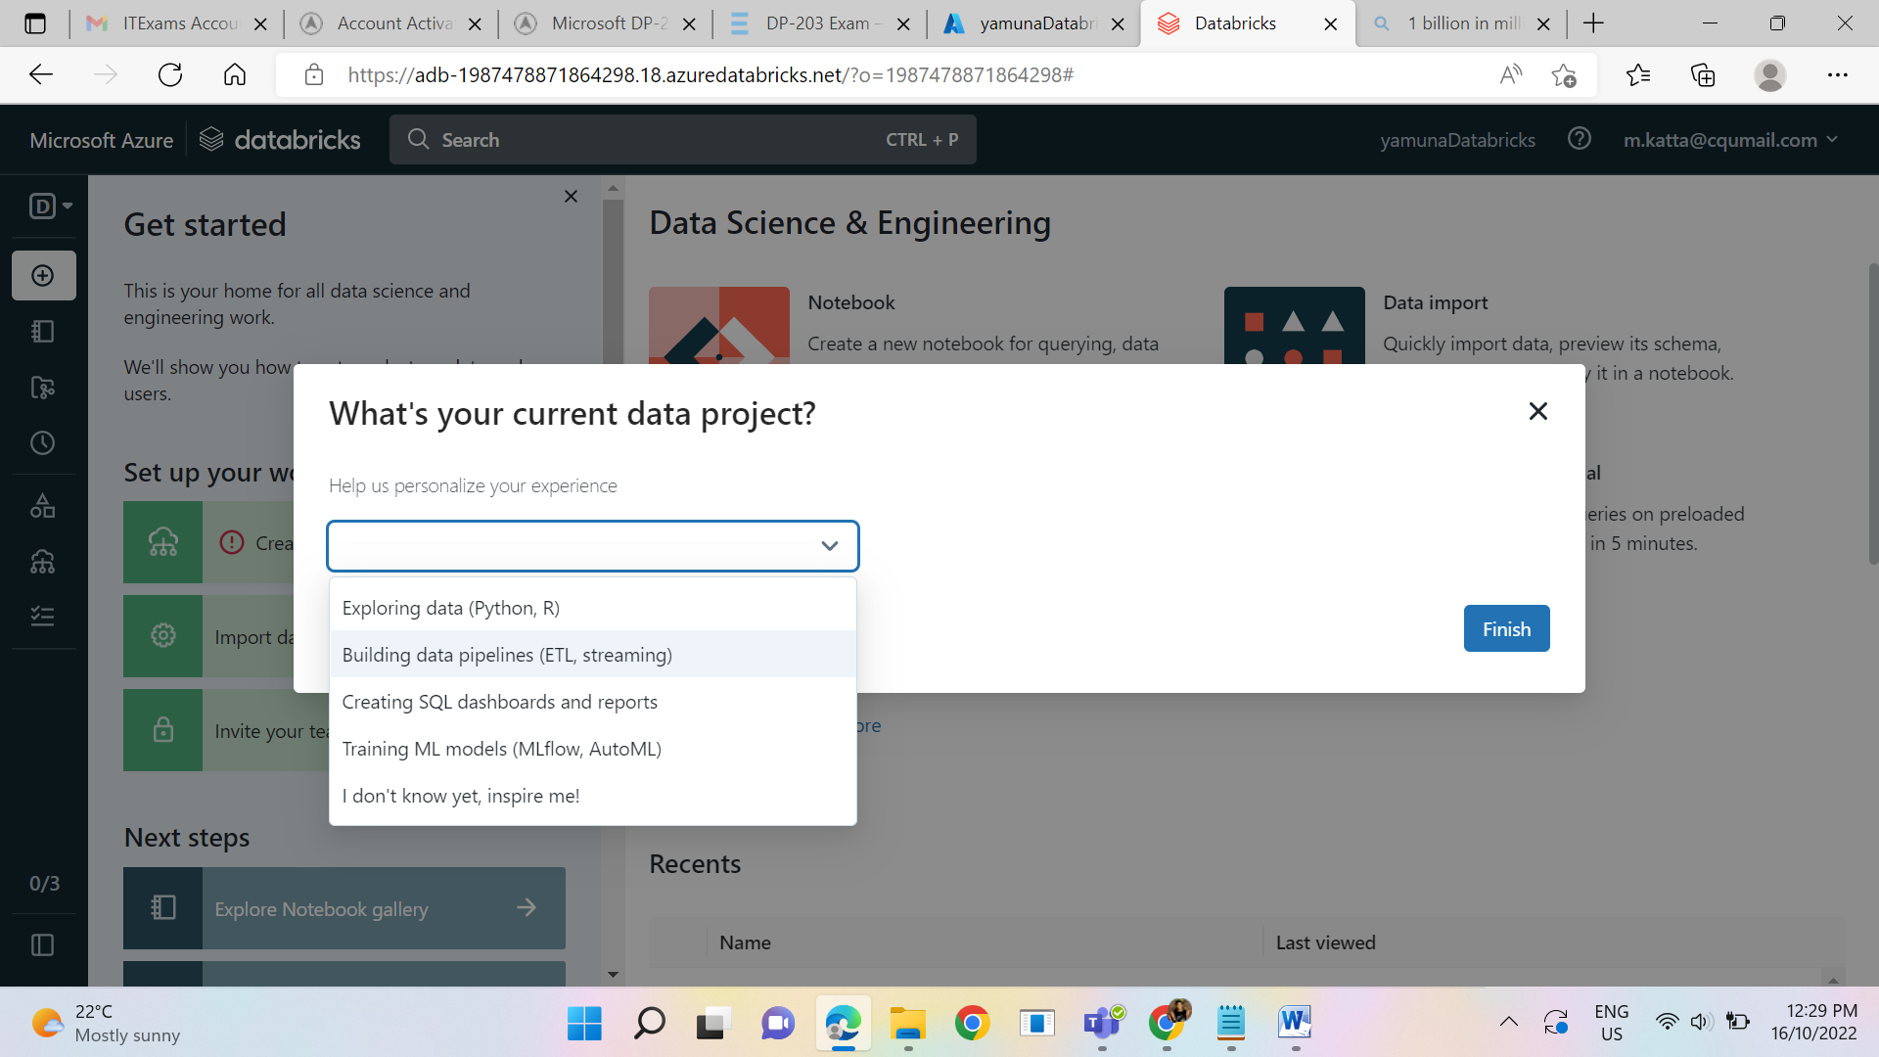

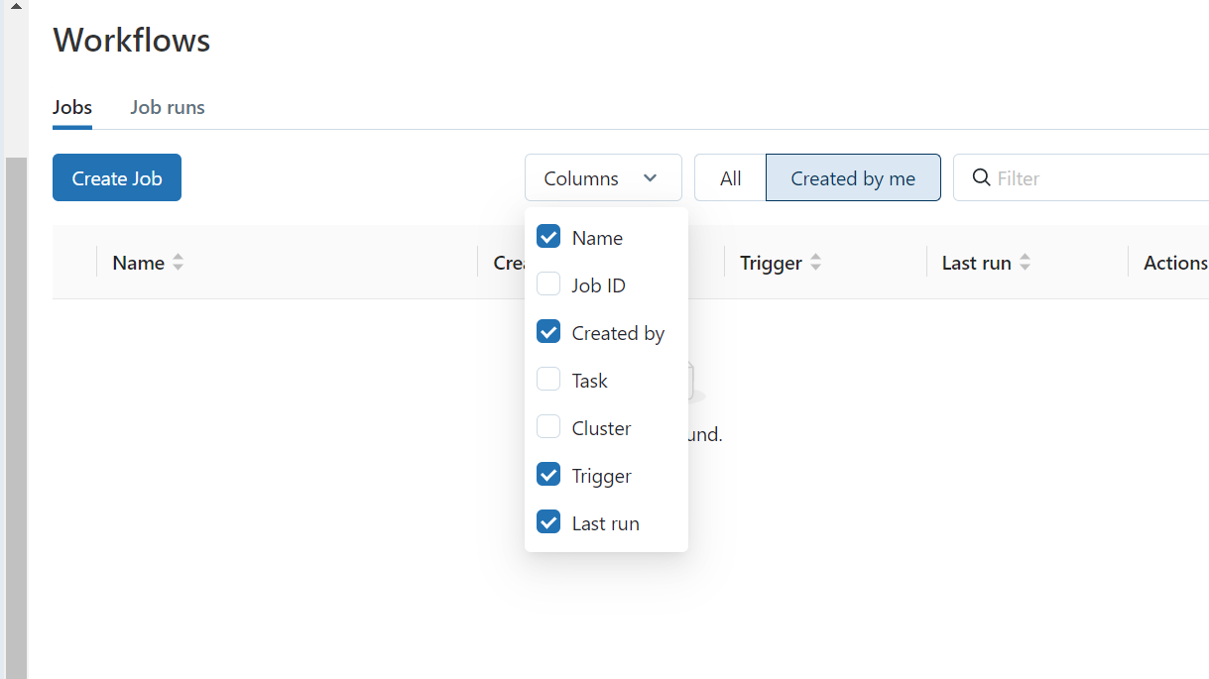

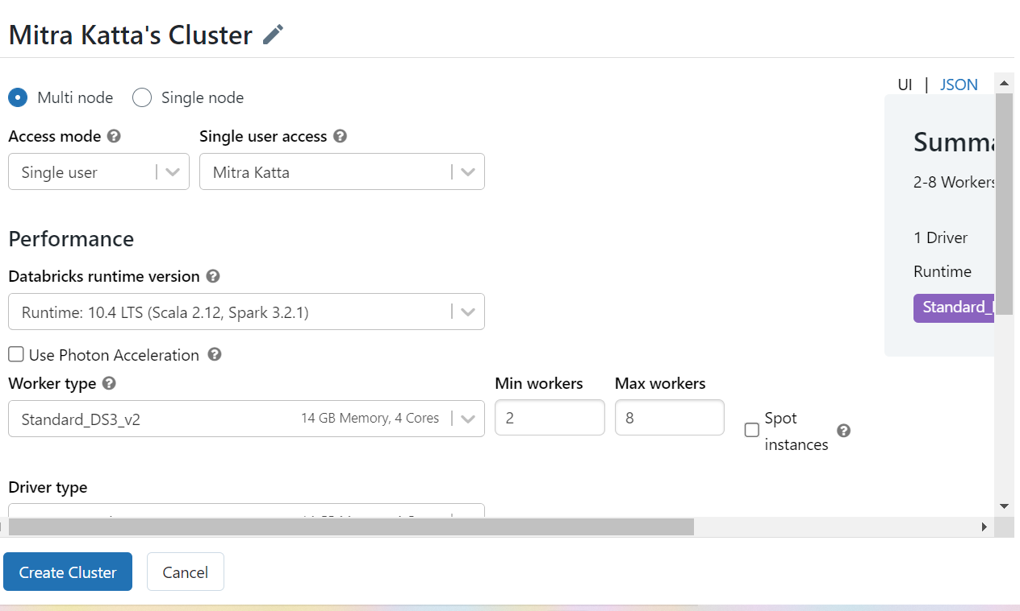

Data bricks Runtime:

Selects the image that will be used to create the cluster. For details about specific images, see the

Photon workload:

Photon accelerates modern Apache Spark workloads, reducing your total cost per workload

What is this delta cache accelerated?

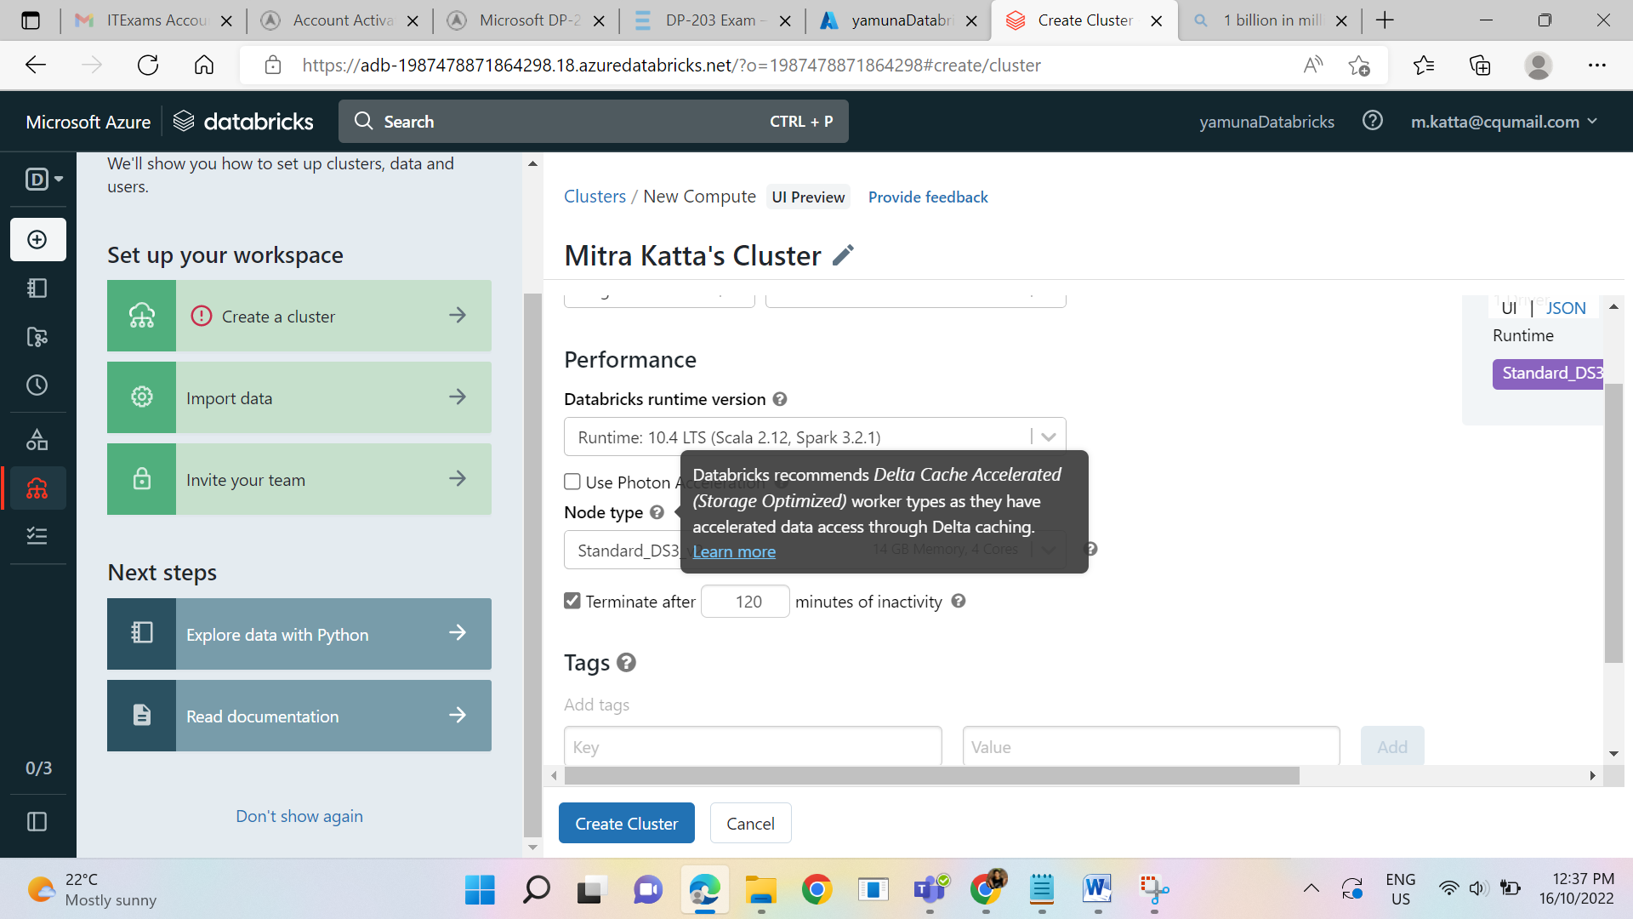

We are having two types of init scripts storage in :

DBFS

ABFSS

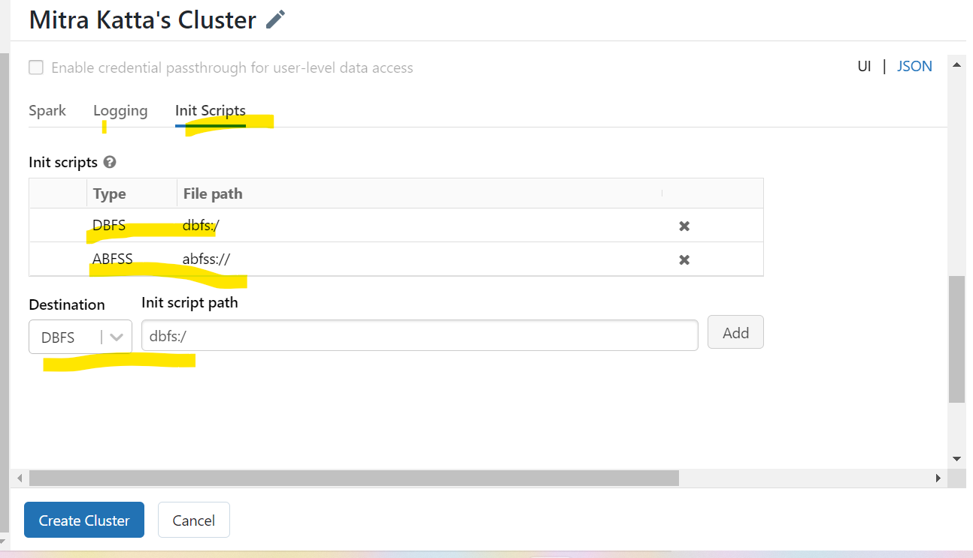

Logging is in DBFS cluster log path:

Dbfs:/cluster-logs

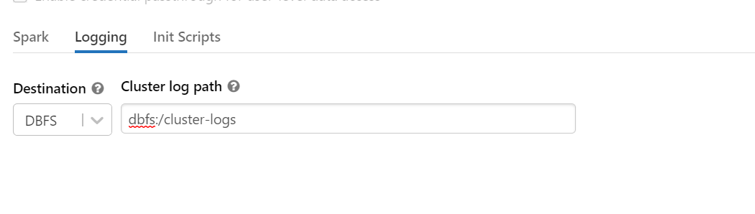

Environment variables needed:

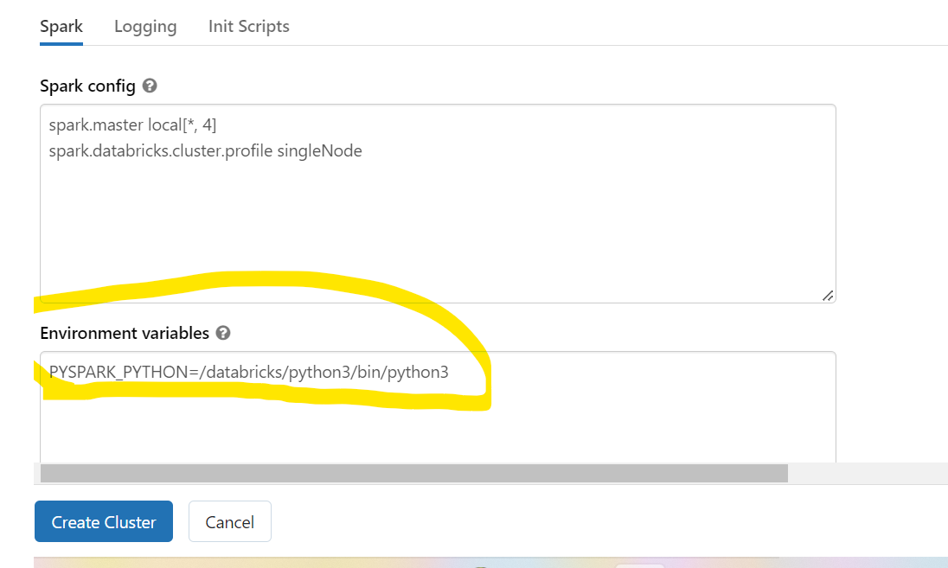

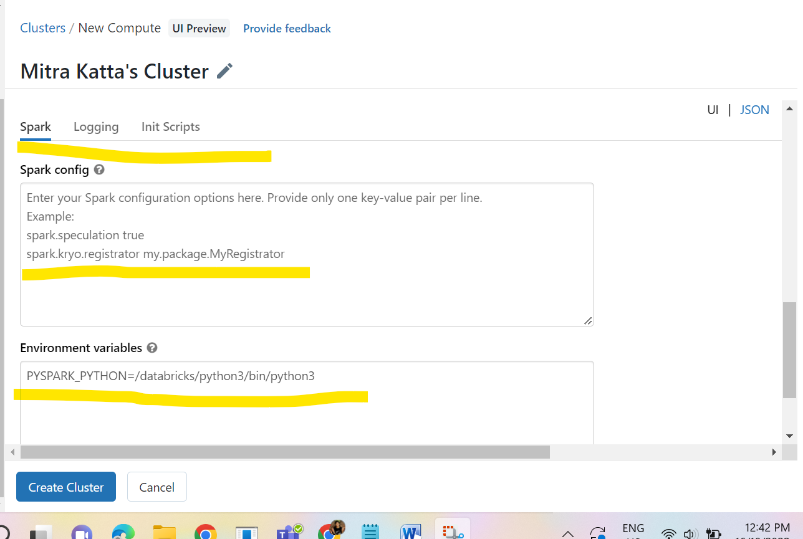

**Jobs configured to run off the latest commit on this branch can be found in the**[**Jobs List**](https://adb-1987478871864298.18.azuredatabricks.net/?o=1987478871864298#job/list)**.**

In the below job creation there is no recurrence and offset in this like tumbling window

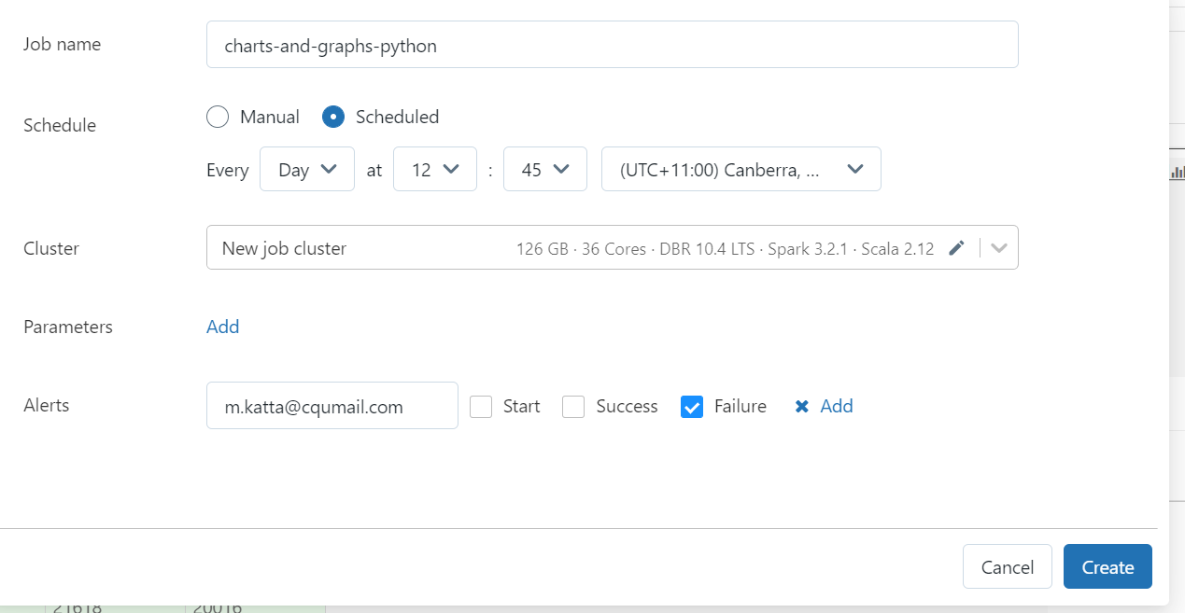

Database creation:

